CIS 83 LAB 1 - RIP v2

Rich Simms

August 29, 2006

Objective

The objective of this lab is to understand classless routing protocols using RIP v2. This lab shows how RIP V2 addresses the limitation of the classful routing protocol RIP V2 to handle dis-contiguous networks.

Scenario

This lab was done using the basic router pod on NETLAB. NETLAB lets you remotely access a pod of Cisco routers. The three Cisco routers were configured as shown below.

Topology

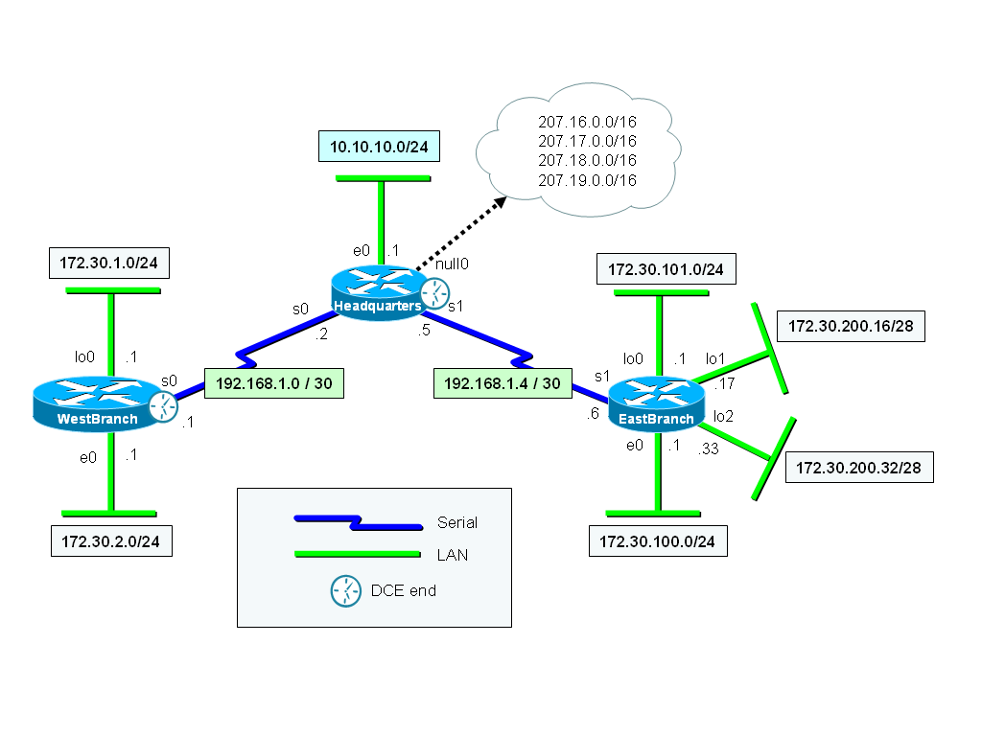

Final Running Configurations

WestBranch | Headquarters | EastBranch
version 12.2  service timestamps debug datetime msec  service timestamps log datetime msec  no service password-encryption  !  hostname WestBranch  !  logging queue-limit 100  !  memory-size iomem 15  ip subnet-zero  !  !  no ip domain lookup  !  ip audit notify log  ip audit po max-events 100  !  interface Loopback0  ip address 172.30.2.1 255.255.255.0  !  interface BRI0  no ip address  shutdown  !  interface FastEthernet0  ip address 172.30.1.1 255.255.255.0  speed auto  !  interface Serial0  ip address 192.168.1.1 255.255.255.252  clockrate 64000  !  interface Serial1  no ip address  shutdown  !  !  !  !  router rip  version 2  network 172.30.0.0  network 192.168.1.0  no auto-summary  !  !  ip classless  no ip http server  no ip http secure-server  !  !  !  line con 0  exec-timeout 0 0  logging synchronous  line aux 0  line vty 0 4  !  no scheduler allocate  end | version 12.2  service timestamps debug datetime msec  service timestamps log datetime msec  no service password-encryption  !  hostname Headquarters  !  logging queue-limit 100  !  memory-size iomem 15  ip subnet-zero  !  !  no ip domain lookup  !  ip audit notify log  ip audit po max-events 100  !  interface FastEthernet0  ip address 10.10.10.1 255.255.255.0  speed auto  !  interface Serial0  ip address 192.168.1.2 255.255.255.252  !  interface Serial1  ip address 192.168.1.5 255.255.255.252  clockrate 64000  !  !  !  !  !  !  !  !  !  !  !  !  router rip  version 2  redistribute static  network 10.0.0.0  network 192.168.1.0  no auto-summary  !  ip classless  ip route 207.16.0.0 255.255.0.0 Null0  no ip http server  no ip http secure-server  !  line con 0  exec-timeout 0 0  logging synchronous  line aux 0  line vty 0 4  !  no scheduler allocate  end | version 12.2  service timestamps debug datetime msec  service timestamps log datetime msec  no service password-encryption  !  hostname EastBranch  !  logging queue-limit 100  !  memory-size iomem 15  ip subnet-zero  !  !  no ip domain lookup  !  ip audit notify log  ip audit po max-events 100  !  interface Loopback0  ip address 172.30.101.1 255.255.255.0  !  interface Loopback1  ip address 172.30.200.17 255.255.255.240  !  interface Loopback2  ip address 172.30.200.33 255.255.255.240  !  interface FastEthernet0  ip address 172.30.100.1 255.255.255.0  speed auto  !  interface Serial0  no ip address  shutdown  !  interface Serial1  ip address 192.168.1.6 255.255.255.252  !  router rip  version 2  network 172.30.0.0  network 192.168.1.0  no auto-summary  !  !  ip classless  no ip http server  no ip http secure-server  !  !  !  line con 0  exec-timeout 0 0  logging synchronous  line aux 0  line vty 0 4  !  no scheduler allocate  end

Final Routing Tables

WestBranch | WestBranch#show ip route  Codes: C - connected, S - static, R - RIP, M - mobile, B - BGP  D - EIGRP, EX - EIGRP external, O - OSPF, IA - OSPF inter area  N1 - OSPF NSSA external type 1, N2 - OSPF NSSA external type 2  E1 - OSPF external type 1, E2 - OSPF external type 2  i - IS-IS, L1 - IS-IS level-1, L2 - IS-IS level-2, ia - IS-IS inter area  * - candidate default, U - per-user static route, o - ODR  P - periodic downloaded static route  Gateway of last resort is not set  172.30.0.0/16 is variably subnetted, 6 subnets, 2 masks  R 172.30.200.32/28 [120/2] via 192.168.1.2, 00:00:02, Serial0  R 172.30.200.16/28 [120/2] via 192.168.1.2, 00:00:02, Serial0  C 172.30.2.0/24 is directly connected, Loopback0  C 172.30.1.0/24 is directly connected, FastEthernet0  R 172.30.100.0/24 [120/2] via 192.168.1.2, 00:00:02, Serial0  R 172.30.101.0/24 [120/2] via 192.168.1.2, 00:00:02, Serial0  10.0.0.0/24 is subnetted, 1 subnets  R 10.10.10.0 [120/1] via 192.168.1.2, 00:00:03, Serial0  192.168.1.0/30 is subnetted, 2 subnets  C 192.168.1.0 is directly connected, Serial0  R 192.168.1.4 [120/1] via 192.168.1.2, 00:00:03, Serial0  R 207.16.0.0/16 [120/1] via 192.168.1.2, 00:00:03, Serial0  WestBranch#
Headquarters | Headquarters#show ip route  Codes: C - connected, S - static, R - RIP, M - mobile, B - BGP  D - EIGRP, EX - EIGRP external, O - OSPF, IA - OSPF inter area  N1 - OSPF NSSA external type 1, N2 - OSPF NSSA external type 2  E1 - OSPF external type 1, E2 - OSPF external type 2  i - IS-IS, L1 - IS-IS level-1, L2 - IS-IS level-2, ia - IS-IS inter area  * - candidate default, U - per-user static route, o - ODR  P - periodic downloaded static route  Gateway of last resort is not set  172.30.0.0/16 is variably subnetted, 6 subnets, 2 masks  R 172.30.200.32/28 [120/1] via 192.168.1.6, 00:00:16, Serial1  R 172.30.200.16/28 [120/1] via 192.168.1.6, 00:00:16, Serial1  R 172.30.2.0/24 [120/1] via 192.168.1.1, 00:00:01, Serial0  R 172.30.1.0/24 [120/1] via 192.168.1.1, 00:00:01, Serial0  R 172.30.100.0/24 [120/1] via 192.168.1.6, 00:00:16, Serial1  R 172.30.101.0/24 [120/1] via 192.168.1.6, 00:00:16, Serial1  10.0.0.0/24 is subnetted, 1 subnets  C 10.10.10.0 is directly connected, FastEthernet0  192.168.1.0/30 is subnetted, 2 subnets  C 192.168.1.0 is directly connected, Serial0  C 192.168.1.4 is directly connected, Serial1  S 207.16.0.0/16 is directly connected, Null0  Headquarters#
Eastbranch | EastBranch#show ip route  Codes: C - connected, S - static, R - RIP, M - mobile, B - BGP  D - EIGRP, EX - EIGRP external, O - OSPF, IA - OSPF inter area  N1 - OSPF NSSA external type 1, N2 - OSPF NSSA external type 2  E1 - OSPF external type 1, E2 - OSPF external type 2  i - IS-IS, L1 - IS-IS level-1, L2 - IS-IS level-2, ia - IS-IS inter area  * - candidate default, U - per-user static route, o - ODR  P - periodic downloaded static route  Gateway of last resort is not set  172.30.0.0/16 is variably subnetted, 6 subnets, 2 masks  C 172.30.200.32/28 is directly connected, Loopback2  C 172.30.200.16/28 is directly connected, Loopback1  R 172.30.2.0/24 [120/2] via 192.168.1.5, 00:00:26, Serial1  R 172.30.1.0/24 [120/2] via 192.168.1.5, 00:00:26, Serial1  C 172.30.100.0/24 is directly connected, FastEthernet0  C 172.30.101.0/24 is directly connected, Loopback0  10.0.0.0/24 is subnetted, 1 subnets  R 10.10.10.0 [120/1] via 192.168.1.5, 00:00:26, Serial1  192.168.1.0/30 is subnetted, 2 subnets  R 192.168.1.0 [120/1] via 192.168.1.5, 00:00:28, Serial1  C 192.168.1.4 is directly connected, Serial1  R 207.16.0.0/16 [120/1] via 192.168.1.5, 00:00:28, Serial1  EastBranch#

Summary

This lab explored RIP v1 and v2 routing protocols and how it is configured on Cisco routers. It also went into the next levels of supernetting (summarization) and subnetting subnets (VLSM) from what we learned in CIS 82.

The lab clearly illustrates the advantages of RIP v2 over RIP v1. The biggest advantage is that discontiguous networks can be handled. This addresses a problem with classful routing where the router thinks (erroneously) that there is more that one correct path to a network. The resulting load balancing behavior results in a portion of the packets getting misrouted. This is addressed in RIP v2 because the network masks are included in the routing updates and there is an option to disable automatic summarization (supernetting to reduce the size of routing tables).

RIP v2 also using multicasts rather than broadcasts to send routing table updates. This is one less packet every host on a network will have to check.

This lab also explored aspects of supernetting and VLSM. For supernetting we created a single default routing table entry to handle four separate “fake” networks attached to the Headquarters router using a null interface. The redistribute static command insured this information was included in routing updates sent from this router. On the EastBranch router we added some VLSM networks which was really just subnetting one of the subnets further using a longer mask.

NETLAB lets you remotely access three routers remotely. To make more complicated topologies within NETLAB limitations, loopback and null interfaces were used. All packets that are sent to the null interface get dropped.

I had some initial problems with NETLAB when I tried to paste IOS commands into my local Telnet interface. This worked last semester but this time when I pasted too many commands at once the Telnet session would hang and then disconnect without NETLAB knowing. Restating the Telnet session did not work because NETLAB would block it saying you had already made the connection. The workaround was to use the Connection tab in NETLAB and disconnect all sessions and then restart them again. Pasting was successful if only a few commands at a time were pasted.

Commands

! Configuring RIP v1
conf t
router rip
! add only directly connected classful network for RIP to advertise
network 192.168.4.0
network 172.30.0.0
! undo any mistakes
no network 172.30.0.0

!propogate default GW (worked on lab routers, not on NetLAb)
default-information originate

!propogate default GW (works on NetLab & lab)
redistribute static

!suppress announcements to stub networks
passive-interface e0

! tracing RIP updates
debug ip rip
undebug ip rip
undebug all

!RIP v2
conf t
router rip
version 2
no auto-summary
network 192.168.2.0
network 192.168.3.0

! Disabling RIP
conf t
no router rip

! Suppressiong IOS annoyances for lab environment
line con 0
logging synchronous
exec-timeout 0 0
exit

